What is a Classifier?
- It is a machine learning model which can be trained and predicts the output based on input datasets.
Types of Classifiers:
- KNN (K-Nearest Neighbours)
- HTM (Hierarchical Temporal Memory)

- KNN: It is a distance-based classifier, supervised learning algorithm, used for classification and regression.
In K-Nearest Neighbours (KNN), the "K" represents the number of nearest neighbours considered when making a classification or regression prediction.

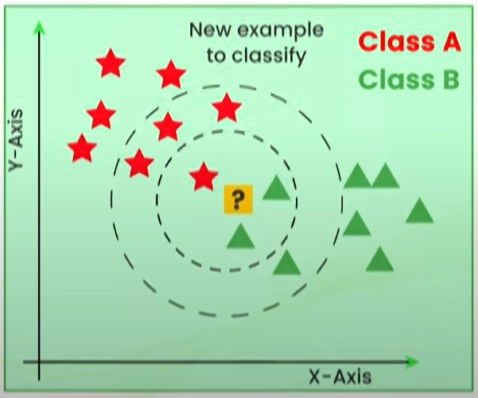
Figure 1: example of KNN

In the Figure 1, the inner circle and outer circle contains 3 and 7 nearest neighbours respectively.

